­

2022_ GGE_5403

Web Mapping and Geospatial Web Services



Assignment 4

Prepared by:  
Mohammadali Rahnama

Student number:

3709515

# TABLE OF CONTENTS

TABLE OF CONTENTS 1

LIST OF FIGURES 1

Introduction 2

GeoPackage (GPKG) 2

GPKG File Format 2

Canada Geospatial Data Extraction Tool 2

QGIS 3

Metadata 4

Road Junction Layer 5

Road Segments Layer 7

Water Body Layer 9

REFERENCES 11

# LIST OF FIGURES

Figure 1: Metadata 4

Figure 2: Road junction layer information 5

Figure 3: Road junction layer table 6

Figure 4: Road junction layer preview 6

Figure 5: Road segments layer information 7

Figure 6: Road segments layer table 8

Figure 7: Road segments layer preview 8

Figure 8: Water body layer information 9

Figure 9: Water body layer table 10

Figure 10: Water Body layer preview 10

# Introduction

## GeoPackage (GPKG)

A .gpkg file is a geographical information system that is implemented as an SQLite database container and contains data and metadata tables with standard definitions, format limitations, integrity assertions, and content constraints. It was defined by the OGC (Open Geospatial Consortium) on behalf of the US military and published in 2014. The GeoPackage has widespread support from a variety of government, commercial, and open-source organizations [1].

### GPKG File Format

A standard defines a set of rules (required conventions) for [1]:

* Keeping imagery in tile matrix sets
* Characteristics of vector
* At various scales, raster maps
* Schema and metadata

The extension rules described in clause 2.3 of the standard can be used to extend a GeoPackage. The goal of creating a GeoPackage was to create a database that was as light as possible and include it in a single file that was ready to use. This makes it ideal for off-line mobile apps and quick sharing via cloud storage or USB storage devices, among other things [1].

## Canada Geospatial Data Extraction Tool

Natural Resources Canada's Canadian Geospatial Data Extraction tool is a useful tool that all geospatial users in Canada should be familiar with. It enables users to extract continuous geospatial open data based on a user-defined geographic area and data options. While downloading authoritative topographic and elevation data for use in their projects, this gives the user complete control [2].

Users can extract topographic data from the CanVec series, which includes over 60 topographic features organized into eight main themes, using the Canadian Geospatial Data Extraction tool (transportation features, administrative features, hydrographic features, land features, man-made features, elevation features, resources management features, and toponymic features). It is based on the most up-to-date data sources and provides high-quality topographic data in vector format that meets international geomatics standards. CanVec data can be used for extensive spatial analysis as well as cartographic design because of its many attributes [2].

## QGIS

QGIS (until 2013 known as Quantum GIS) is a free and open-source cross-platform desktop geographic information system (GIS) application that supports viewing, editing, and analysis of geospatial data [3].

QGIS functions as geographic information system (GIS) software, allowing users to analyze and edit spatial information, in addition to composing and exporting graphical maps. QGIS supports both raster and vector layers; vector data is stored as either point, line, or polygon features. Multiple formats of raster images are supported, and the software can georeferenced images [3].

QGIS supports shapefiles, coverages, personal geodatabases, dxf, MapInfo, PostGIS, and other formats. Web services, including Web Map Service and Web Feature Service, are also supported to allow use of data from external sources [3].

# Metadata

The following is the metadata of the extracted CanVec hydrographic and transportation features of the GeoPackage file for the Gloucester, NB geographic area:

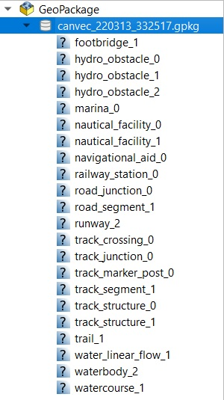

Figure 1: Metadata

# Road Junction Layer

The following is a visualization of the road junction layer of the Gloucester, NB geographic area GeoPackage file, as well as an excerpt from the attribute tables:

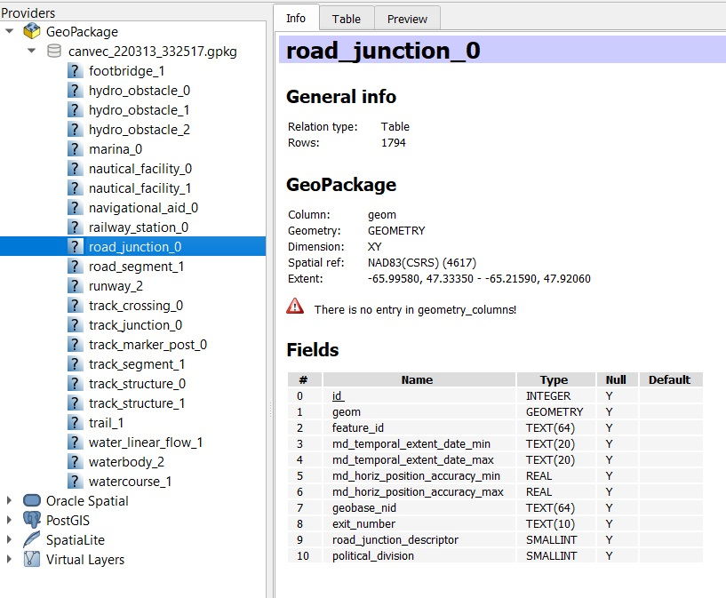

Figure 2: Road junction layer information

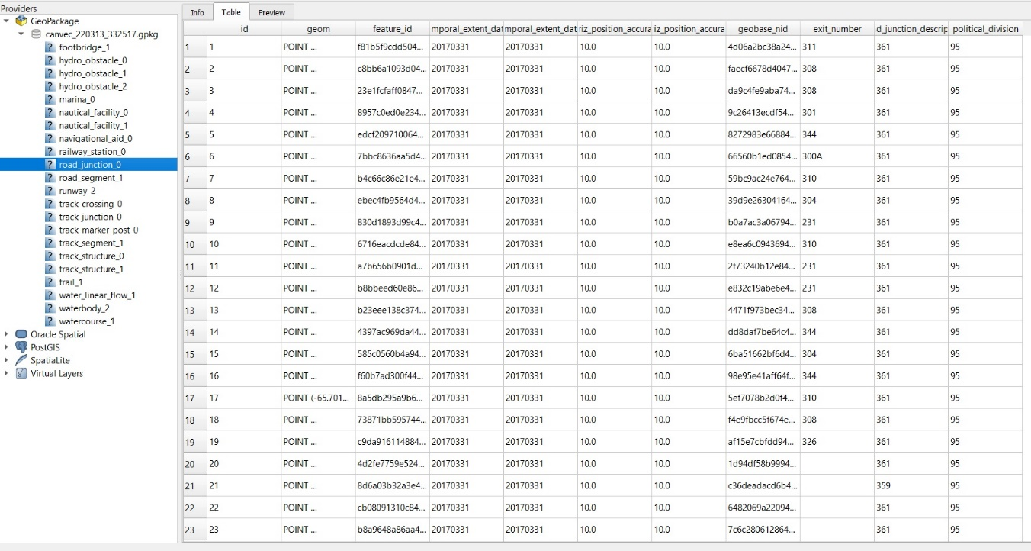

Figure 3: Road junction layer table

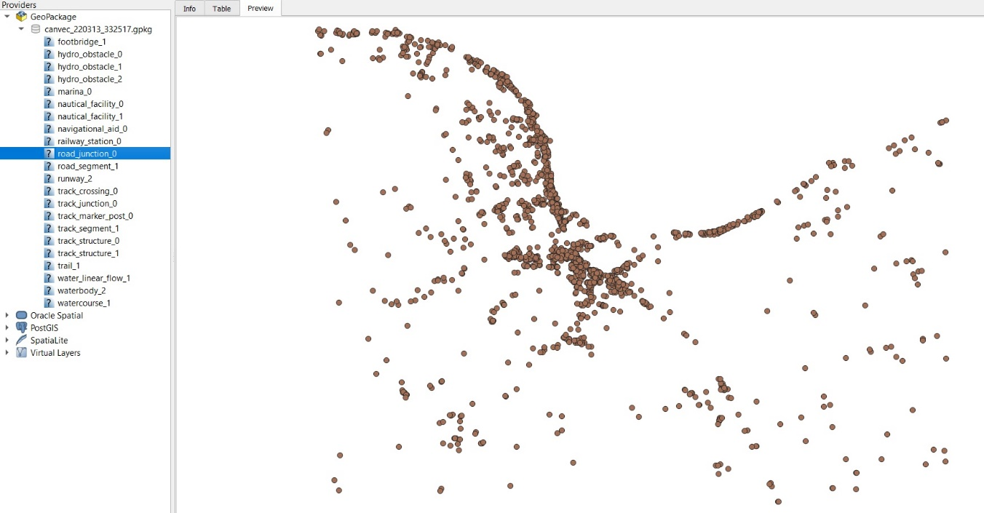

Figure 4: Road junction layer preview

# Road Segments Layer

The following is a visualization of the road segments layer of the Gloucester, NB geographic area GeoPackage file, as well as an excerpt from the attribute tables:

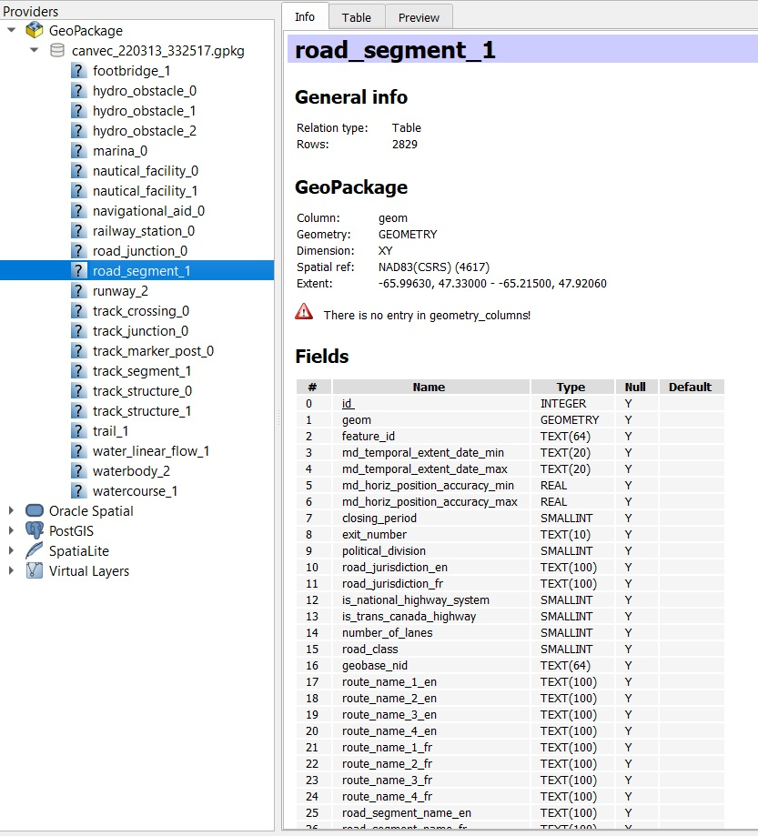

Figure 5: Road segments layer information

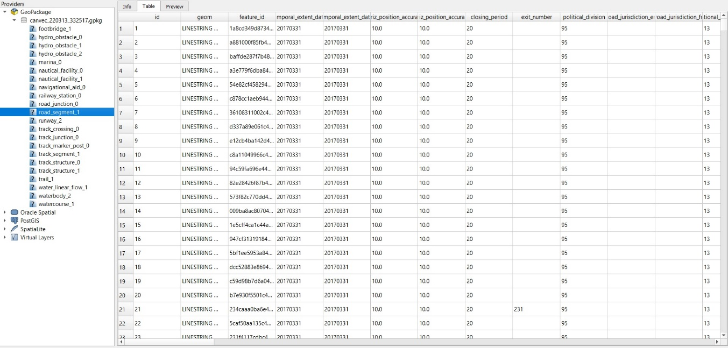

Figure 6: Road segments layer table

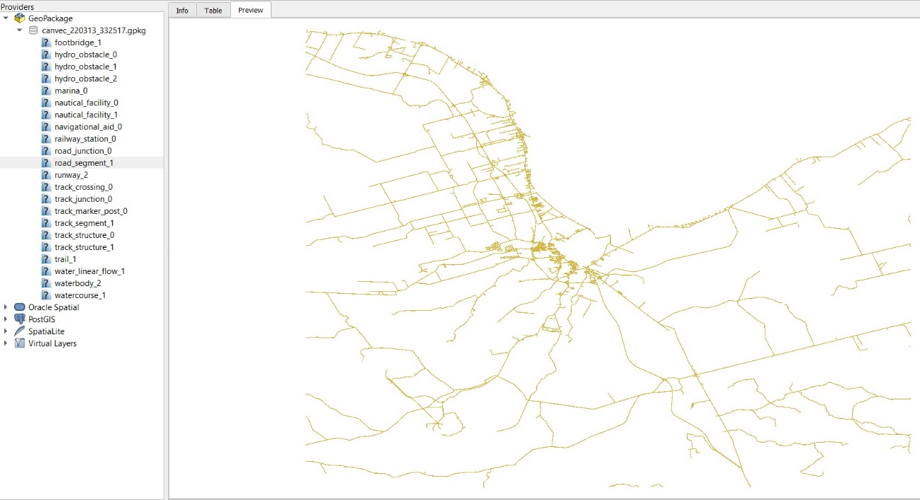

Figure 7: Road segments layer preview

# Water Body Layer

The following is a visualization of the water body layer of the Gloucester, NB geographic area GeoPackage file, as well as an excerpt from the attribute tables:

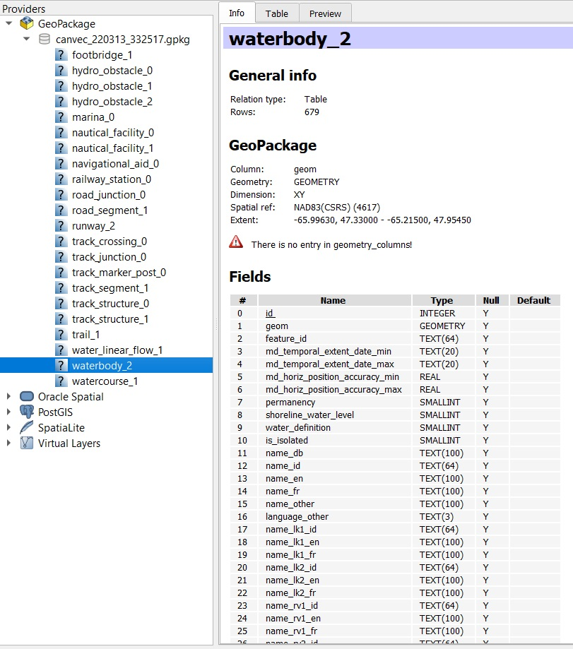

Figure 8: Water body layer information

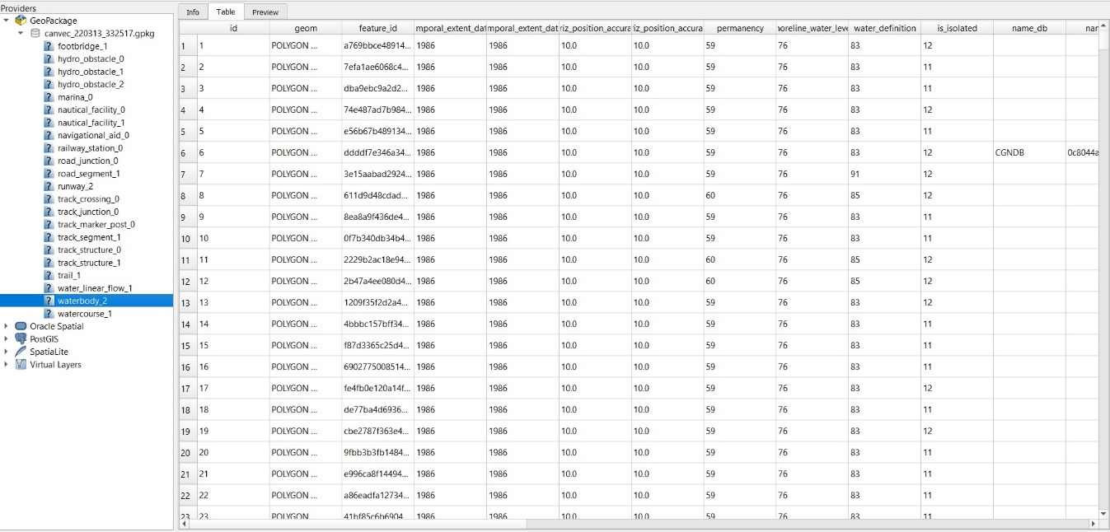

Figure 9: Water body layer table

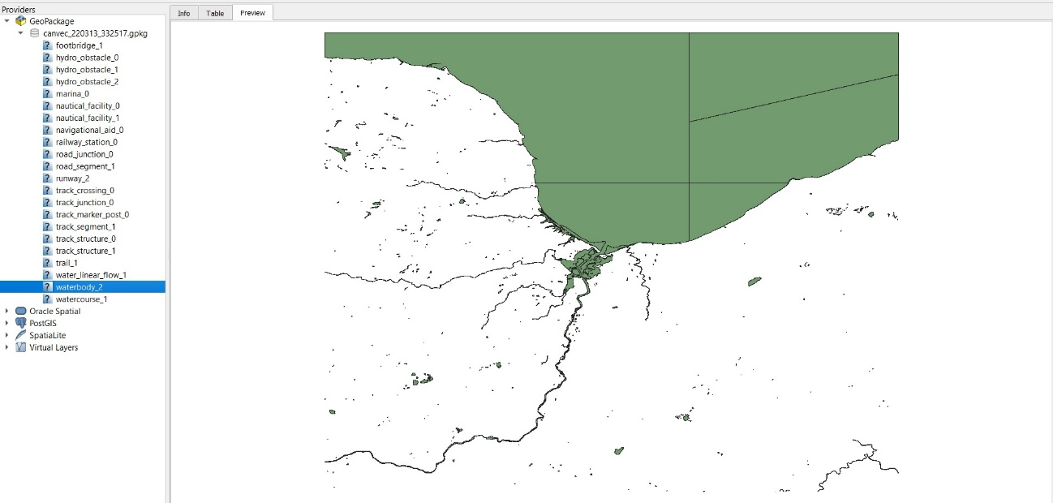

Figure 10: Water Body layer preview

# REFERENCES

[1] M. Umar, “GPKG - GeoPackage format files,” *GPKG - GeoPackage Format Files*. Jul. 2021, [Online]. Available: https://docs.fileformat.com/gis/gpkg/.

[2] Canadian GIS and Geomatics, “Canadian {Geospatial} {Data} {Extraction} {Tool},” *Canadian GIS \& Geomatics*. Dec. 2019, Accessed: Mar. 13, 2022. [Online]. Available: https://canadiangis.com/canadian-geospatial-data-extraction-tool.php.

[3] Wikipedia, “QGIS,” *Wikipedia*. Jan. 2022, Accessed: Mar. 13, 2022. [Online]. Available: https://en.wikipedia.org/w/index.php?title=QGIS&oldid=1064006339.